Collin Real

DA 6823

Kilger

Module 2: Part #2 (55 points)

**Standard Error of the Estimate + Confidence Intervals + the Logic of Hypothesis Testing + Type 1 and Type II errors**

**General Instructions:** In your own words, answer each of the following questions - don’t copy (e.g. cut and paste) some definition out of a book word for word. This is not a group project – you are expected to complete this module on your own. You may refer to text books, online or other sources but not your fellow classmates. If you don’t understand the question, feel free to ask the instructor in class, in office hours or in an email.

1. Explain in your own words what a type I error is (4 points)

A type I error incorrectly rejects the null hypothesis, leading to a false positive conclusion. This error might falsely conclude that the relationship between dependent and independent variables was statistically significant, but the results were actually influenced by other random factors/errors.

1. Explain in your own words what a type II error is (4 points)

A type II error does not reject the null hypothesis when it should, leading to a false negative conclusion. This error occurs when there was a significant effect in the results, but the conclusion claimed no significance.

1. Imagine that you are a cancer researcher who has developed a new test for cancer. Think about what a type I and type II error means for this kind of test. Argue for what you think is the most egregious error – a type I or type II error in this case. (Hint – you can logically argue for either case, just explain why). (6 points)

Type I is the most egregious error because it would create a false positive conclusion that a new treatment for cancer provided a cure when it actually does not. If the patient’s cancer started going into remission during the new treatment period, the null hypothesis would be rejected because of the supposed significant effect of the treatment. However, if a random factor actually caused the cancer cells to stop growing rather than the treatment, the researchers incorrectly rejected the null hypothesis.

1. Explain in your own words what the power of a statistical test means (4 points)

The power of a statistical test is the likelihood of incorrectly rejecting the null hypothesis (i.e. the probability of making a correct decision to avoid a Type II error). Power is also the likelihood of a significance test correctly identifying that an effect is present.

1. Name two things that can affect the power of a statistical test (4 points)

Significance level and sample size

1. Here are the six steps of hypothesis testing:
   * 1. State the null (Hnull) and alternative (Halt) hypotheses
     2. State the assumptions of the test
     3. Determine the critical value for the test statistic
     4. Calculate the value of the test statistic from the data
     5. Compare the calculated and critical values for the test statistic
     6. Apply the decision rule and interpret the result of the test

We will use a simple chi-square test as our example in this module. Here is the data that examines if there is a relationship between gender and format of book read:

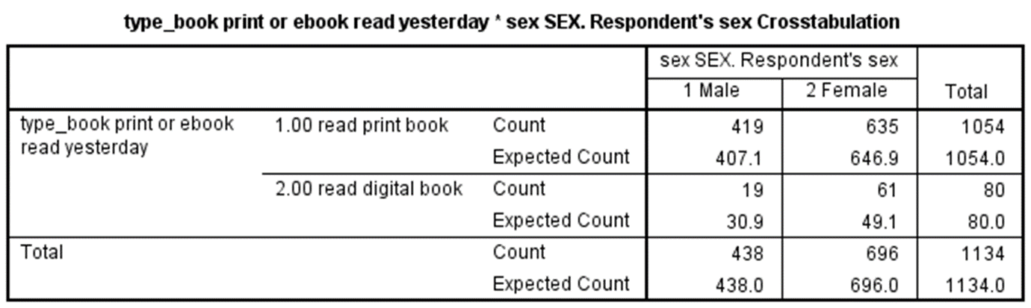

The questions on the next page take you through each step applying the chi-square test to this data. Use a stats book and/or the Internet to help you with this but write your answers in your own words, not copy and paste.

1. State the null and alternative hypotheses for this test. (4 points)

Null: Gender is independent of book format.

Alternative: Gender is not independent of book format.

1. State at least one assumption for this test. (3 points)

Independent groups, categorical variables, mutually exclusive categories

1. Determine the critical value of chi-square that your data will have to exceed in order to reject the null hypothesis. This involves calculating the degrees of freedom for our data as well as looking up the critical value in a chi-square table. Show your work for calculation degrees of freedom. (6 points)

Total rows = 2

Total columns = 2

Degrees of freedom for chi square test: (row - 1)(columns – 1)

= (2-1)(2-1)

= 1 = df

The chi-square critical value at significance level 0.05 and 1 degree of freedom is 3.841. We will reject the null hypothesis if our calculated chi-square value > critical chi-square value.

1. Write out the chi-square formula and then using the data in the table provided above, calculate the chi-square value from the data. Show your work. (10 points)

1. Compare the chi-square critical value and the chi-square value calculated from the data and draw a rough sketch of a chi square curve and place those two values on the curve. (5 points)

1. Apply the decision rule for the chi-square test and interpret the result of your analysis. (5 points)

Since the chi-square calculated value > chi-square critical value, we reject the null hypothesis. The type of book read yesterday and gender are not independent.